# SHORTCUTS

F4 opens the drop-down menue

Spacebar ticks a tick-box on/off

Double Esc deletes the current row entry

F2 same as in Excel

F12 save (a quiry) as …

Control + page down = alt + page down in Excel

# FORMULAS

Date-related formulas

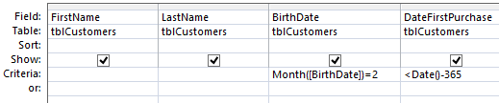

*(PAGE BREAK HERE)*

# QUERIES

Query with Criteria

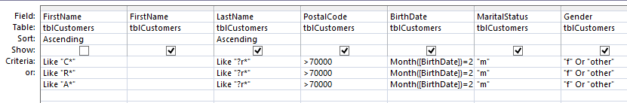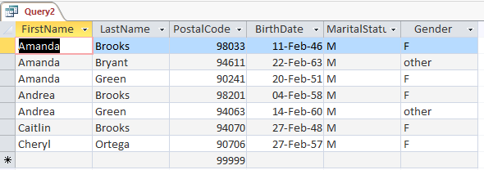

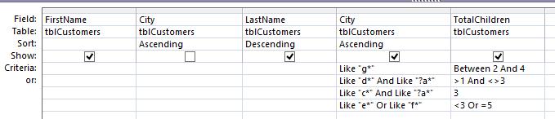

Example Expressions for Criteria

Like '[JG]*'

Like 'ID???-[SR]*'

Between #01/01/2000# And #31/12/2001#

Between 'G' And 'J'

Between 100 And 250

<=#31/12/2011#

Like '*/?4/2012' (keep in mind there can be difference between date and its format, i.e. how it is displayed)

Month([Purchase Date])=3

Getting the User to apply a filter

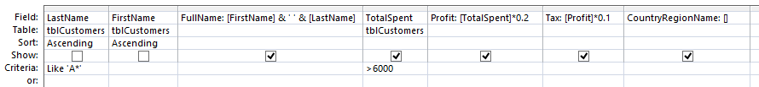WRONG:

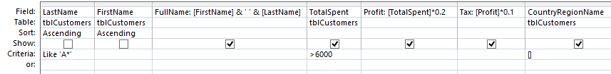CORRECT:

SELECT [FirstName] & ' ' & [LastName] AS FullName, tblCustomers.TotalSpent, [TotalSpent]*0.2 AS Profit, [Profit]*0.1 AS Tax, tblCustomers.CountryRegionName

FROM tblCustomers

WHERE (((tblCustomers.LastName) Like 'A*') AND ((tblCustomers.TotalSpent)>6000) AND ((tblCustomers.CountryRegionName)=[]))

ORDER BY tblCustomers.LastName, tblCustomers.FirstName;

Applying Filters

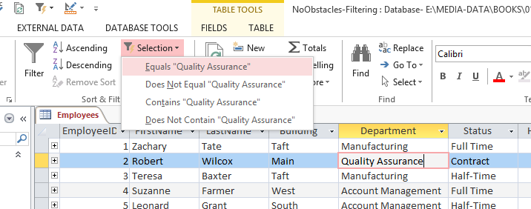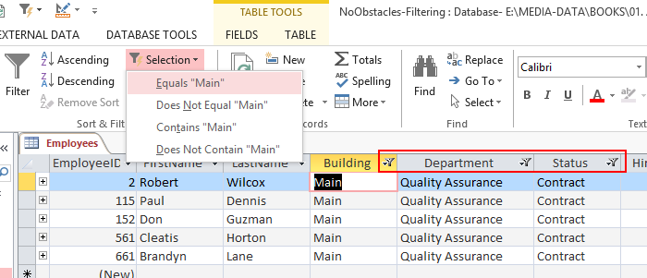

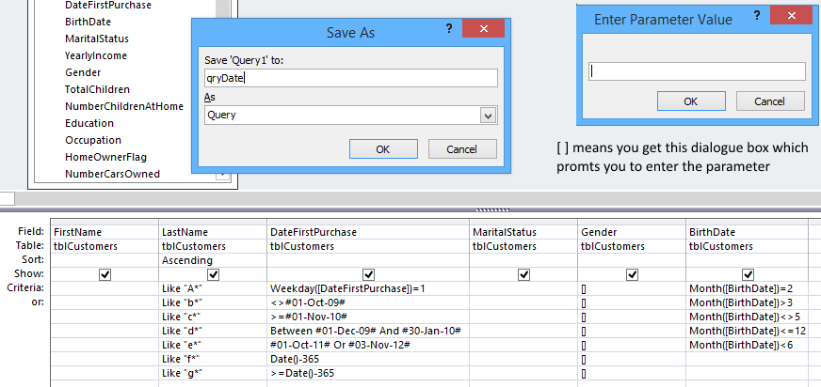Save as query

Wild cards for dates

(all purchases in August)

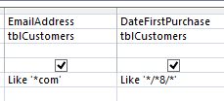

Is Null

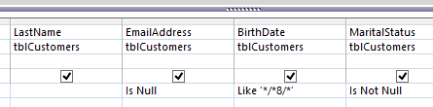

And, Or in Queries

these two queries are the same

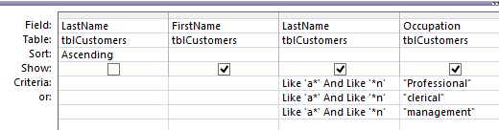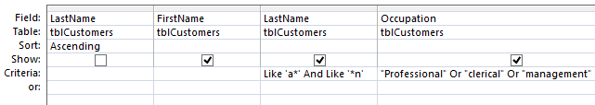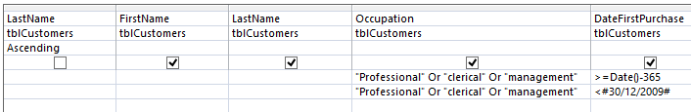

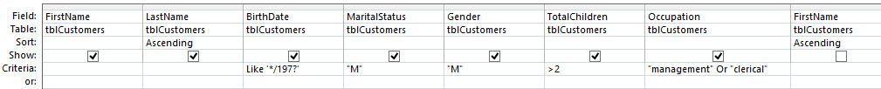Dates in Queries

SELECT tblCustomers.FirstName, tblCustomers.LastName, tblCustomers.BirthDate, tblCustomers.MaritalStatus, tblCustomers.Gender, tblCustomers.TotalChildren, tblCustomers.Occupation

FROM tblCustomers

WHERE (((tblCustomers.BirthDate) Like '*/197?') AND ((tblCustomers.MaritalStatus)="M") AND ((tblCustomers.Gender)="M") AND ((tblCustomers.TotalChildren)>2) AND ((tblCustomers.Occupation)="management" Or (tblCustomers.Occupation)="clerical"))

ORDER BY tblCustomers.LastName, tblCustomers.FirstName;

SELECT FirstName, LastName, BirthDate, MaritalStatus, Gender, TotalChildren, Occupation

FROM tblCustomers

WHERE (((BirthDate) Like '*/197?') AND ((MaritalStatus)="M") AND ((Gender)="M") AND ((TotalChildren)>2) AND ((Occupation)="management" Or (Occupation)="clerical"))

ORDER BY LastName, FirstName;

Calculated Columns

Columns 3,5,6 are calculated

Percentage of at-home children

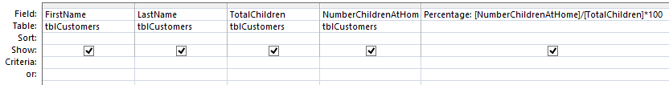

SELECT tblCustomers.FirstName, tblCustomers.LastName, tblCustomers.TotalChildren, tblCustomers.NumberChildrenAtHome, [NumberChildrenAtHome]/[TotalChildren]*100 AS Percentage

FROM tblCustomers;

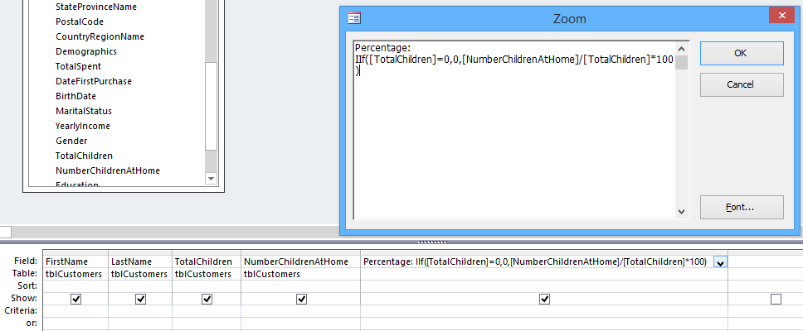IIf – intermediate if

SELECT tblCustomers.FirstName, tblCustomers.LastName, tblCustomers.TotalChildren, tblCustomers.NumberChildrenAtHome, IIf([TotalChildren]=0,0,[NumberChildrenAtHome]/[TotalChildren]*100) AS Percentage

FROM tblCustomers;

Text manipulations in queries

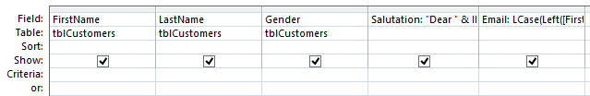

Salutation: "Dear " & IIf([Gender]="M","Mr. ",IIf([Gender]="F","Ms ","Mr./Ms. ")) & [LastName]

Email: LCase(Left([FirstName],1) & "." & [LastName]) & "@mail.com"

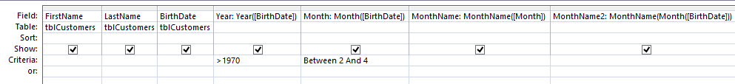Calculating Columns with Date-related formulas

Year(Date)

Month(Date)

MonthName(Integer)

Calculate Age

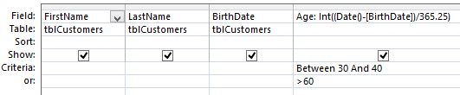

Age: Int((Date()-[BirthDate])/365.25)

SELECT FirstName, LastName, BirthDate, Int((Date()-[BirthDate])/365.25) AS Age FROM tblCustomers;

Total / Group By

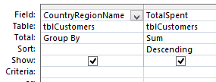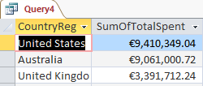

SELECT tblCustomers.CountryRegionName, Sum(tblCustomers.TotalSpent) AS SumOfTotalSpent

FROM tblCustomers

GROUP BY tblCustomers.CountryRegionName

ORDER BY Sum(tblCustomers.TotalSpent) DESC;

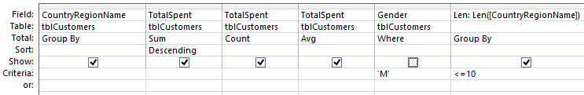Where

SELECT tblCustomers.CountryRegionName, Sum(tblCustomers.TotalSpent) AS SumOfTotalSpent, Count(tblCustomers.TotalSpent) AS CountOfTotalSpent, Avg(tblCustomers.TotalSpent) AS AvgOfTotalSpent, Len([CountryRegionName]) AS Len

FROM tblCustomers

WHERE (((tblCustomers.Gender)='M'))

GROUP BY tblCustomers.CountryRegionName, Len([CountryRegionName])

HAVING (((Len([CountryRegionName]))<=10))

ORDER BY Sum(tblCustomers.TotalSpent) DESC;

Query with user input

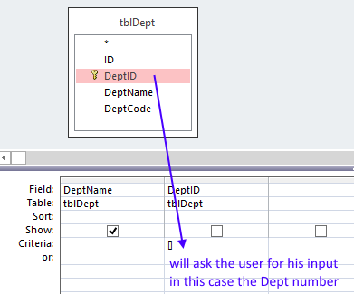

SELECT tblDept.DeptName

FROM tblDept

WHERE (((tblDept.DeptID)=[]));

This works as well:

SELECT tblDept.DeptName FROM tblDept WHERE tblDept.DeptID=[];

Build – Calculated Expressions

SELECT tblEmployee.EmployeeID, [FirstName] & [LastName] AS [Full Name], tblEmployee.Salary, IIf([Salary]>35000,[Salary]*0.25,0) AS Tax

FROM tblEmployee;

# PARAMETER

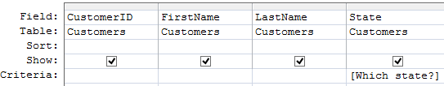

SELECT CustomerID, FirstName, LastName, State

FROM Customers

WHERE State=[Which state?];

Interpret this example:

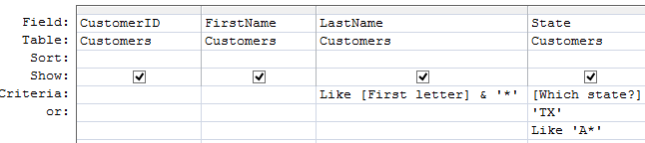

Another example:

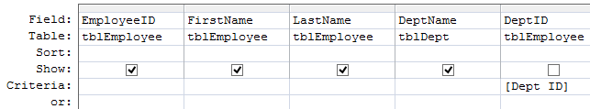

SELECT tblEmployee.EmployeeID, tblEmployee.FirstName, tblEmployee.LastName, tblDept.DeptName

FROM tblDept INNER JOIN tblEmployee ON tblDept.DeptID = tblEmployee.DeptID

WHERE (((tblEmployee.DeptID)=[Dept ID]));

# JOIN

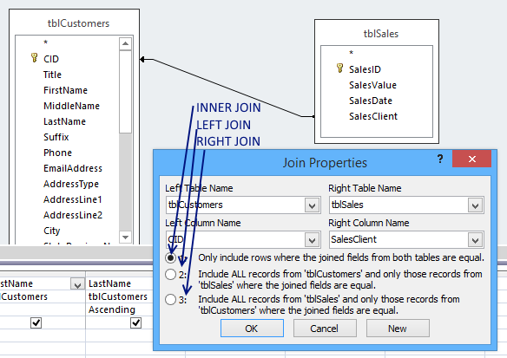

# MANIPULATIVE QUERIES

INSERT INTO tblCountry (CountryName)

SELECT tblCustomers.CountryRegionName

FROM tblCustomers

GROUP BY tblCustomers.CountryRegionName

HAVING (((tblCustomers.CountryRegionName) Is Not Null))

ORDER BY tblCustomers.CountryRegionName;

# INPUT MASKS

More Info:

<https://support.office.com/en-us/article/Control-data-entry-formats-with-input-masks-E125997A-7791-49E5-8672-4A47832DE8DA>

# LOOKUP

Make a field unique

<https://support.office.com/en-gb/article/Prevent-duplicate-values-in-a-field-b5eaace7-6161-4edc-bb90-39d1a1bc5576>

CREATE UNIQUE INDEX EmployeeCorpId_index

ON tblEmployee (EmployeeCorpID)

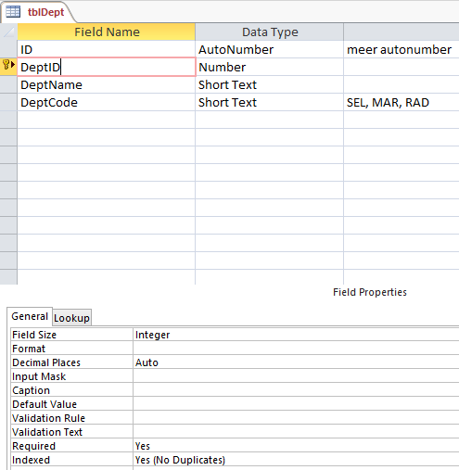

tblDept has a symbolic Primary Key (the Autonumbering [ID]).

The real Primary Key id [DeptID]

[DeptID] must be **Indexed: Yes (No Duplicates)**

Then it can have a one to many relationship with Cascading

Like 'ID???-SEL/??' Or Like 'ID???-MAR/??' Or Like 'ID???-RAD/??'

Like IIf([DeptID]=1,'ID???-SEL/??','ID???-MAR/??')

# VALIDATION

Date Validation

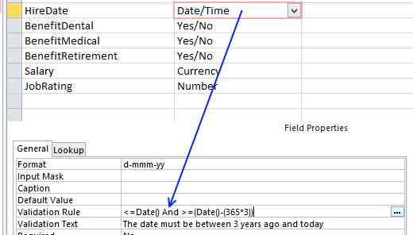

Prohibit the use of numbers and other charecters

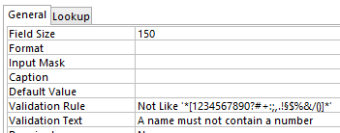

Not Like '*[1234567890?#+:;,.!§$%&/()]*'

Validation using Like

(Like 'ID???-SEL/??' Or Like 'ID???-MAR/??' Or Like 'ID???-RAD/??') And (Not Like 'ID111*')

Mid([ValTest], 2, 3)='abc' (Validation Ruleon the Property Sheet)

Examples

=IIf(1=1,2,3)

=IIf(1=1,2,3) Or >IIf(5=5,1000,100)

Access Validation Rule With Reference To Another Column

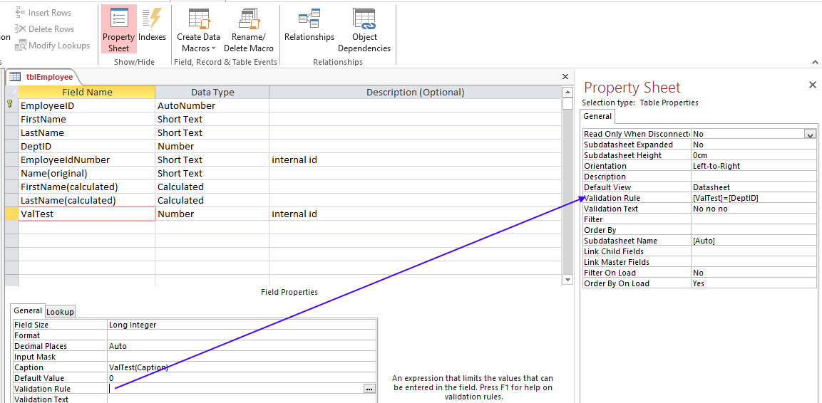Use the Validation Rule on the Property Sheet:

Examples:

[ValTest]=[DeptID] must be equal to the value in a nother field

[ValTest]>=[DeptID]+10

[ValTest] Like '12*'

[ValTest] Like '?AB*'

[ValTest] Like '?AB*' Or [ValTest] Like '*AB?'

[ValTest]=[DeptID] Or [ValTest]>100

Mid([ValTest],2,3)='abc'

Note that these Rules are universal for the whole Table, hence use And/Or for multiple rules